MIDI 30 key Anglo OPERATING INSTRUCTIONS

Contents
1 Equipment supplied 4
2 Basic description 4
3 Midi messages 4
4 Functionality 5
4.1 Mode selection 5
4.2 MIDI Channels 5
4.3 Volume control 5
4.4 Voice selection 5
4.5 Octave selection 6
4.6 Save and Load 6
4.7 System Reset 6
4.8 Emergency All Sound Off 6
5 Start-up 6
6 Voices 8
7 Volume 9
7.1 Bellows Expression 9
8 Octave 10
9 Mode 10
10 Save/Load 11
11 Special Functions 11

Equipment supplied

Lachenal 30 key concertina, modified for General MIDI (GM)

240Vac power supply

Signal/power splitter box

Cable: Splitter box to Concertina cable

Cable: Splitter box to MIDI device (expander/keyboard)

Basic description

The MIDI concertina has been fitted with the required internal electronics to convert it into a fully functional and programmable MIDI instrument.
Externally, a power/signal socket has been added and an LED fitted beneath this to indicate signal status.
An extra bone button has been fitted at the left hand thumb position but otherwise the instrument looks completely normal.
The concertina is airtight and must remain so for correct operation of the bellows, internal air pressure is monitored and used to generate MIDI ‘expression’ messages to vary the volume and to determine the bellows direction, i.e. PUSH or PULL.
The left hand thumb button has been designated as the ‘PROGRAM’ button and the right hand thumb (AIR) button as the ‘PROGRAM 2’ button when ALSO pressed.
The remaining buttons perform the required programming functions when used in conjunction with these two program buttons.
When the ‘PROGRAM’ button is not pressed, the instrument plays as per a normal concertina.

Midi messages

The MIDI concertina generates the following messages;

Note On
Note Off
Control Change Volume
Control Change Expression
Control Change All Sound Off
Program (patch) Change

Functionality

The MIDI concertina has been provided with the following functionality:

Mode selection
The concertina can be selected to operate as a C/G, G/D or Bb/F instrument.

MIDI Channels
The concertina transmits on 4 MIDI channels;

- Channels 1 and 4 are used for the right hand notes only
- Channel 2 is used for notes from BOTH hands
- Channel 3 is used for the left hand notes only

Channels 1,4 and 3 react to bellows pressure.
Channel 2 does NOT react to bellows pressure.

Channels 1 and 4 can be regarded as a single channel and so the concertina is referred to as a 3-channel instrument.
Channel 4 exists as a mimic of channel 1 for those expanders such as the MT32, which does not recognize channel 1 by default.

Volume control
The volume reached by notes played on each of the 3 channels depends on 3 factors;

- Each of the 3 channels has an individual concertina volume control, which sets the channel maximum.
- Channels 1,4 and 3 also respond to bellows ‘expression’ which is a percentage of the channel maximum.
- All 3 channels are then under ultimate control of the expander MASTER volume.

It is recommended that Channel 2 be switched off at the concertina or expander while experimenting with the settings.

Voice selection
15 pre-programmed voices can be selected for EACH of the 3 channels.
These are selected by the customer and programmed into the concertina prior to delivery.

Octave selection
The range of notes playable by each channel of the instrument can also be selected. Each channel can operate 2 octaves low, 1 octave low, normal range or 1 octave high. This is an internal concertina function, no information is sent to the expander.

Save and Load
The complete set of parameters that can be altered can also be saved to memory in the concertina. Each set includes the mode, the 3 channel voices, the 3 channel octaves, and the 3 channel volumes i.e. 10 pieces of information.
It is possible to save and then load 6 sets of parameters.
When the parameters are loaded, they are automatically sent to the expander.

System Reset
The concertina can be restarted if necessary. On restart, the concertina re-checks the bellows ‘NULL’ position and sets the voices to piano, the volumes to half, and the octaves to normal. Information is sent to the expander automatically.

Emergency All Sound Off
Under certain circumstances, MIDI systems can partially fail by falling subject to interference or ‘un-plugging’ in mid performance. In order to regain control of the expander it is possible to send an ‘all sounds off’ message.

Start-up

- Plug the power supply into the splitter box
- Connect the concertina to the splitter box with the cable provided. Make sure that the eight pin silver connector is aligned properly in the concertina socket before tightening the retaining ring; don’t force it.
- Plug the power supply into a wall socket and switch on. The red LED on the power supply will illuminate AND the RED (SENDING) LED on the concertina will also illuminate temporarily.
- Test the concertina is functioning by pressing one or more keys and watching the RED (SENDING) LED. As a key is pressed or released and as the bellows are pushed or pulled, the sending LED will flash to indicate that information is being transmitted from the concertina.
- Connect the splitter box to the MIDI keyboard or expander with the MIDI cable provided.
- Switch on the MIDI keyboard or expander.
- SET THE MIDI KEYBOARD OR EXPANDER TO MIDI OR GM OR GM-MIDI. This last step is ABSOLUTELY ESSENTIAL for correct operation of the concertina. The concertina may work without this step BUT not all of it will work; channels, voices etc may be missing and volume control may not work.
- The concertina should now play using the keyboard start-up voices.

Voices

15 voices have been selected and pre-programmed into the concertina. These can be selected individually for each of the concertina channels and sent to the MIDI expander as follows;

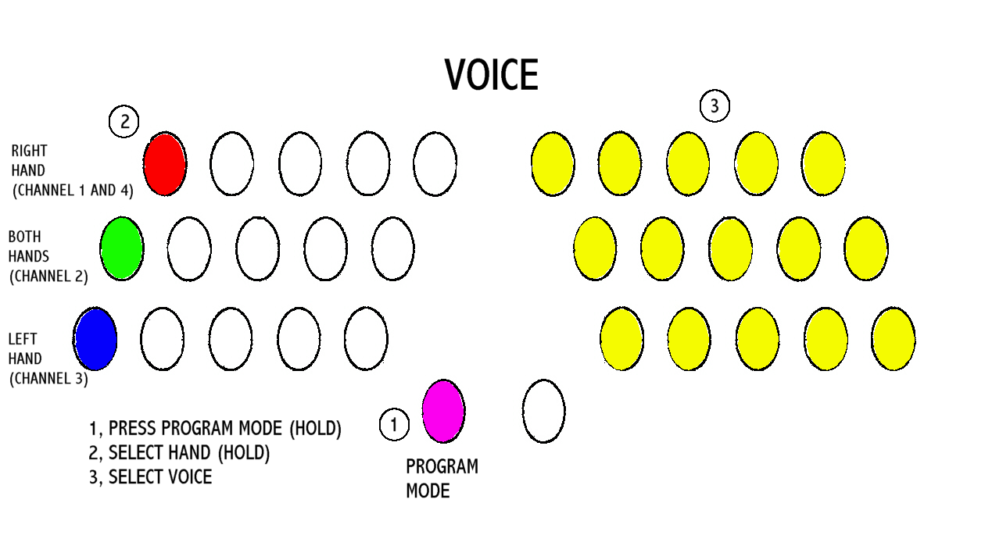

Volume

The individual volume of each of the 3 channels can be changed as follows;
NOTE: selecting ‘OFF’ for a particular channel inhibits ANY information for that channel being sent to the expander or keyboard.

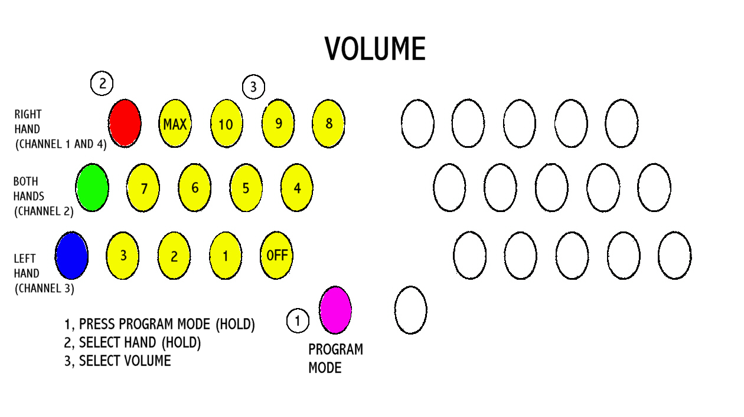

Bellows Expression

Bellows Expression is an automatic function of the bellows and selects a percentage of the volume set above for channels 1,4 and 3 only. Channel 2 does not vary with bellows pressure and operates at fixed volume as selected above.

Octave

The Octave for each of the 3 channels can be changed as follows;
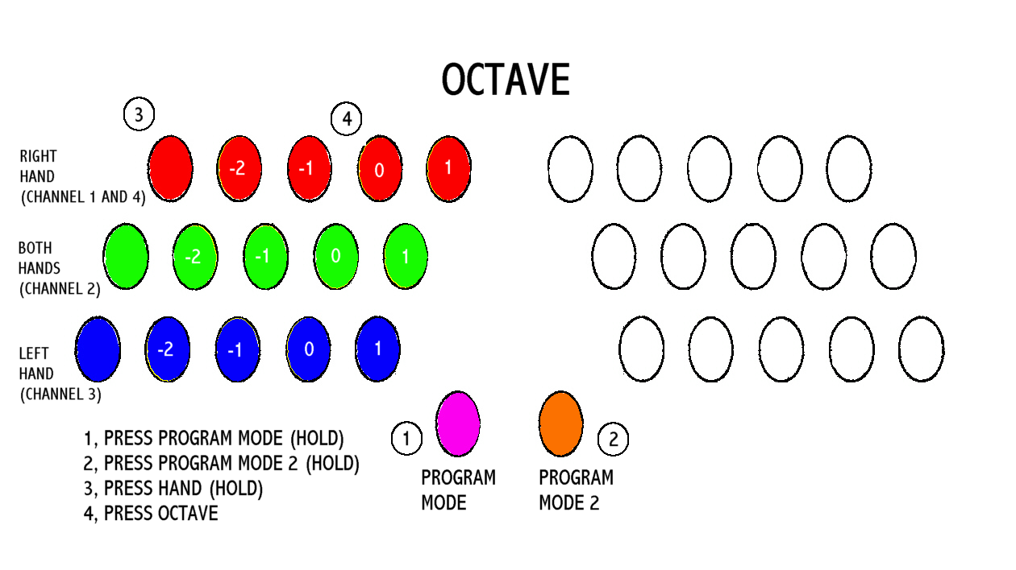

Mode

The concertina has three modes of operation; C/G, G/D or Bb/F, and these can be selected as follows;
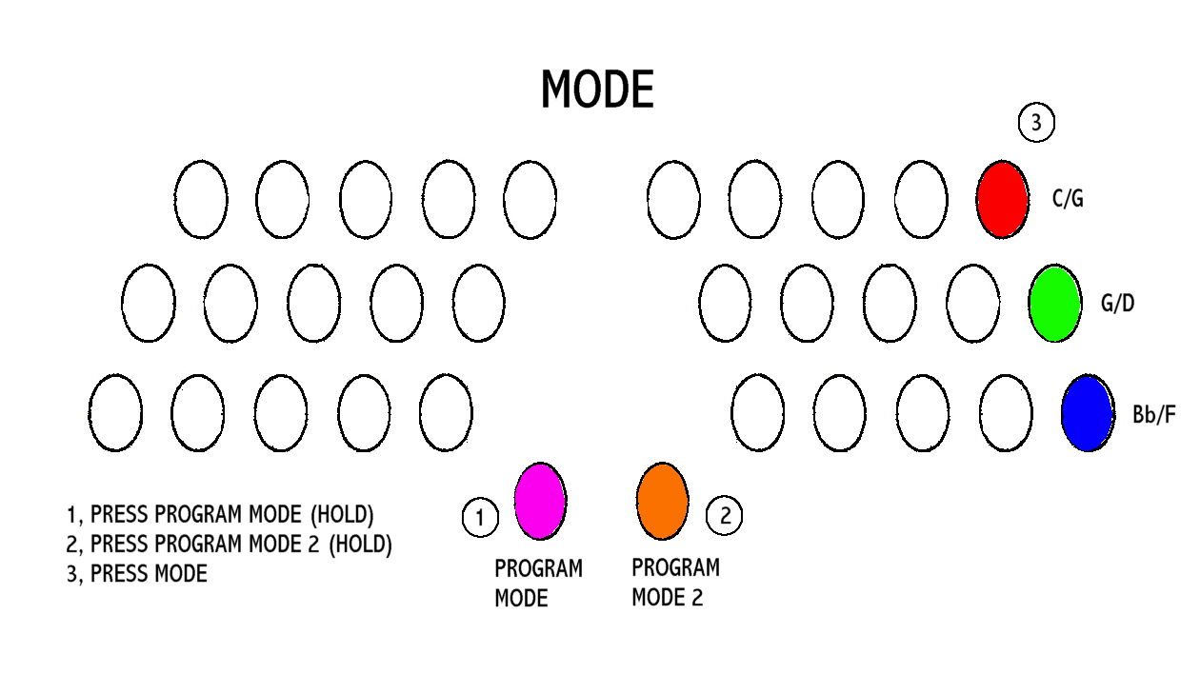

Save/Load

It is possible to save the concertina settings and to retrieve the same as follows:
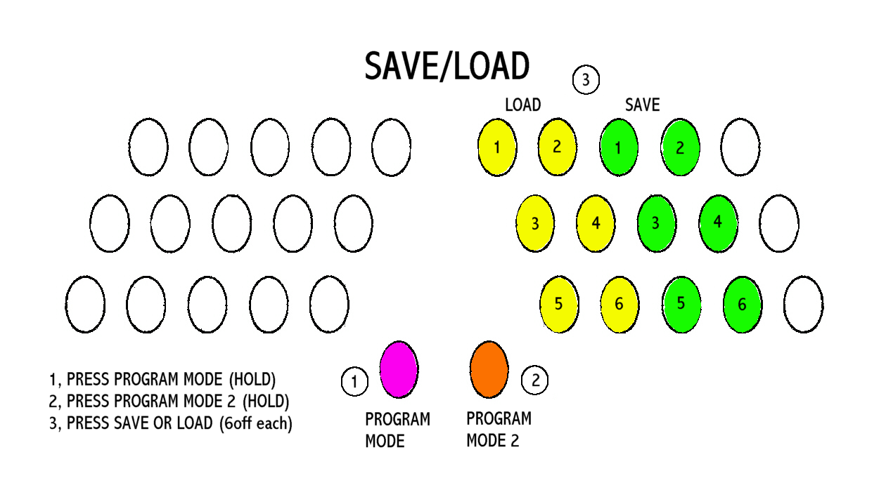

Special Functions

